**TRAFFIC MANAGEMENT SYSTEM**

**BLOCK DIAGRAM:**

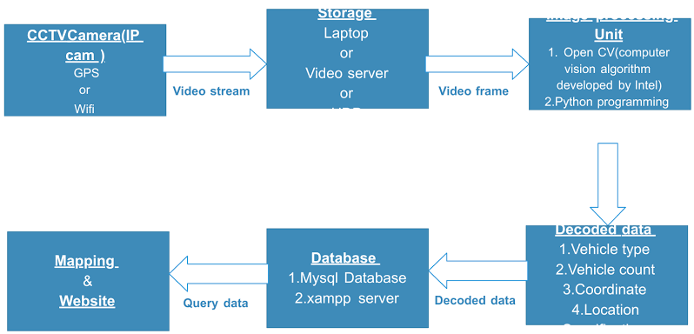

Block diagram for traffic management system

**CIRCUIT DIAGRAM:**

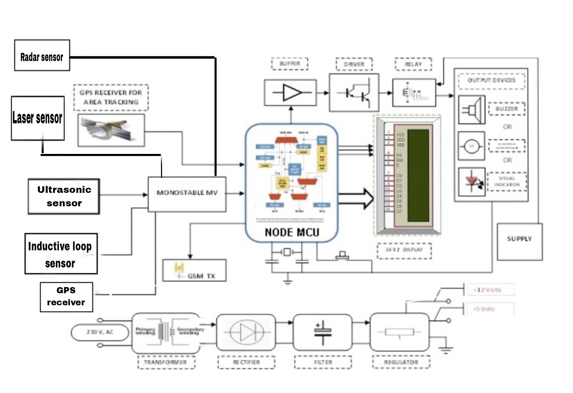

**Circuit diagram for traffic management system**

**FLOWCHART:**

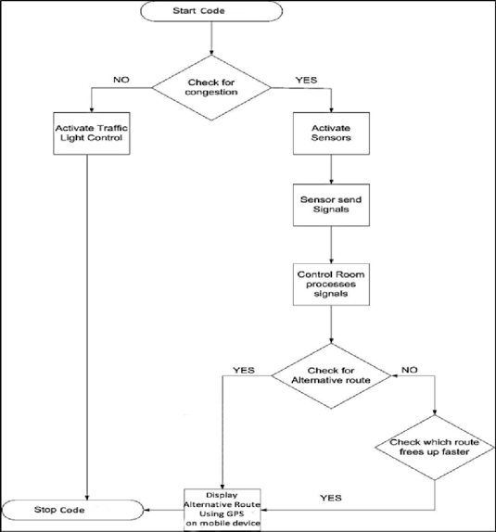

Flowchart for traffic control management

**SENSORS USED IN TRAFFIC MANAGEMENT SYSTEM:**

1.Ultrasonic sensors.

2.GPS receivers.

3.Radar sensor.

4.Laser sensor.

5.Inductive loop sensor.

**ULTRASONIC SENSORS:**

Ultrasonic sensors are sound waves with freqencies above the human hearing range to measure distance or detect objects .They emit ultrasonic pulses and calculate distance based on the time it takes for the sound waves to bounce back .Commonly used in robotics and automation for proximity sensing and and object avoidance.

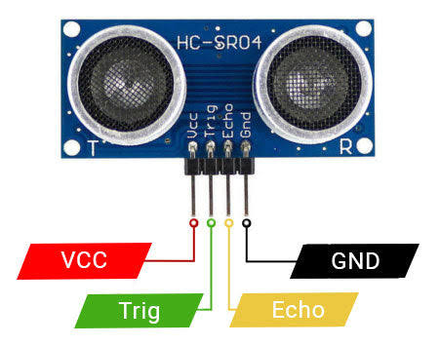

Diagram for ultrasonic sensor

**GPS RECEIVER:**

GPS(Global Positioning System) receivers are devices that use signals from satellites to determine and display the user’s precise location,speed and direction. They receives signals from multiple satellites and by triangulating the signals ,the GPS receiver calculates the user’s position on earth .These receivers are widely used in navigation systems,smartphones,vehicles and various other applications for location-based services .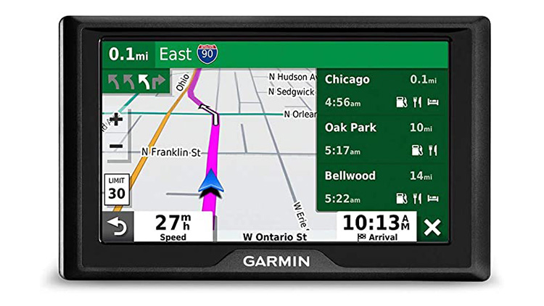

Diagram for GPS receiver.

**RADAR SENSOR:**

Radar sensor use radio waves to detect objects and their motion.They’re employed various applications ,from weather monitoring to automotive collision avoidance systems.

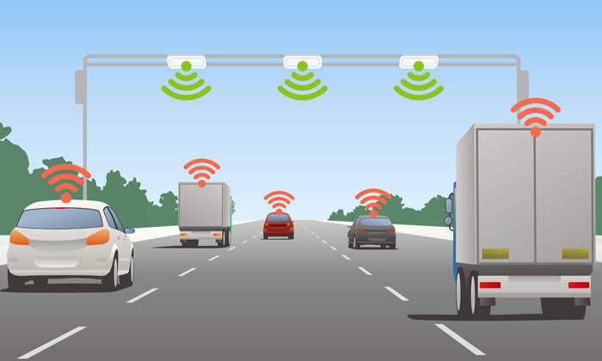

Diagram for radar sensor

LASER SENSOR:

It is used for vehicle detection and monitoring .They can measure the distance between the sensor and the vehicle ,aiding in traffic flow control ,signal timing,and vehicle counting .These sensors contribute to efficient traffic management by providing real-time data.

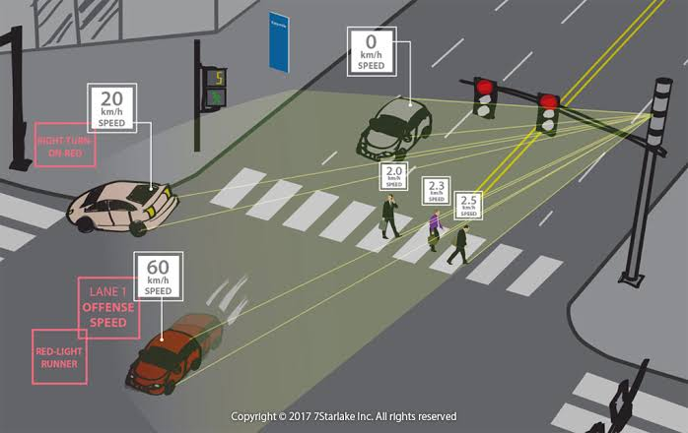

Diagram for laser sensor

**INDUCTIVE LOOP SENSOR:**

These sensors consist of loops of wire embedded in the road surface. When a vehicle with metal components passes over the loop,it induces a change in the inductance,triggering the sensor.These are often employed at intersections for traffic signal control,toll booths and parking lots.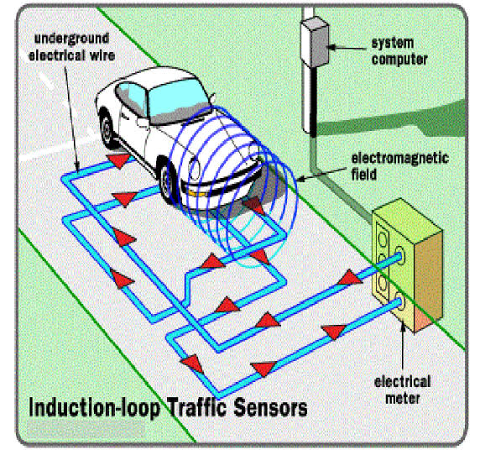

Diagram for Inductive loop sensor